# 2017-03-24 MoM MSc Thesis Exploration Julia Filler

|  |  |
| --- | --- |
| Location | **Office HG 0111** |
| Date, Time | **2017-03-24, 10:00 - 11:30** |

|  |  |
| --- | --- |
| Participants | Julia Filler (JFi) Juergen Musil (JM) |

|  |  |
| --- | --- |
| Distributed to | Participants, Stefan Biffl (SB), Angelika Musil (AM) |

### Points of Discussion

**Title Candidates**

* Crowdwork
* Crowdworker
* Support (Self-) Organization
* Usability
* Support
* Improvement
* Social Computing
* Gigwork
* An approach to support knowledge sharing and self-organization in crowdworker communities
* An system/tool/platform/mechanisms to support self-organization in crowdworker communities

**Context**

* Crowdwork
* CIS / Social Platforms

**Motivation**

* Problem: Most platforms are either not under EU jurisdiction or there are yet no regulations in place to takle the inequalities (e.g. with regards to labour rights).
  + Therefore: need for lightweight solution that supports crowdworker in addition to future labour rights regulations.
  + Idea: Problem is caused by a software platform, therefore another software platform might be part of the solution.
    - Counteract the negative effects caused by the origin platform (in this case the crowdsourcing platform).
* Support Crowdworker with knowledge sharing + the issues raised in AK study.
  + See additional material provided by JM.
* Ideal situation / goal: Support crowdworkers AND connect Interessensvertreter and crowdworkers in some way.
* Find out how to use CIS and other CSCW-like systems how/when/where to support crowdworker.

**Stakeholders, Their Goals and Challenges**

* Crowdworker
  + What to earn money with crowdwork tasks, that they could not do otherwise.
* Interessensvertreter of Crowdworker
  + Regard crowdwork as an important societal topic of Digitalization (Digitalisierung) and want to protect worker rights also in this emerging domain.
  + Two types:
    - Goverment Organizations: Arbeiterkammer, Ministerien
    - Political Organizations: Worker Unions (ÖGB, IGMetall)
* Political Decision Makers
  + Have to react to the crowdwork issue, because it makes their constituents unhappy (and then they might vote for somebody else).
* Crowdsourcing Platform Operators
  + Want to preserve the status quo.
* Requester
  + Don't care what happens as long as service and price remains unchanged or gets cheaper.

**Criteria for a Good Solution**

* Identification of factors that are important for coordination and knowledge sharing support for Crowdworker.
  + ?? Maybe also check semantic knowledge sharing for worker records accross crowdsourcing platforms (just a paragraph in the related work).
* A toolkit/platform that allows crowdworkers of a particular community (= community around a particular platform or domain).

**Alternative Solution Approaches, Their Strengths and Limitations**

* Keep everything as it is.
  + Describe why this is NOT an option.
* Forums and other platforms
  + Not good why?
  + List limitations
    - usability
    - limited to only the most promintent platforms -smaller ones are neglected or event completely not address
* Platform provider provide solutions themselves
  + Risk that they most likely indirectly/subtly exert control on crowdwokers.
    - Maybe: Get input vom AK/ÖGB on this issue form other domains (same scenarios in traditional industries (Metallarbeiter)).

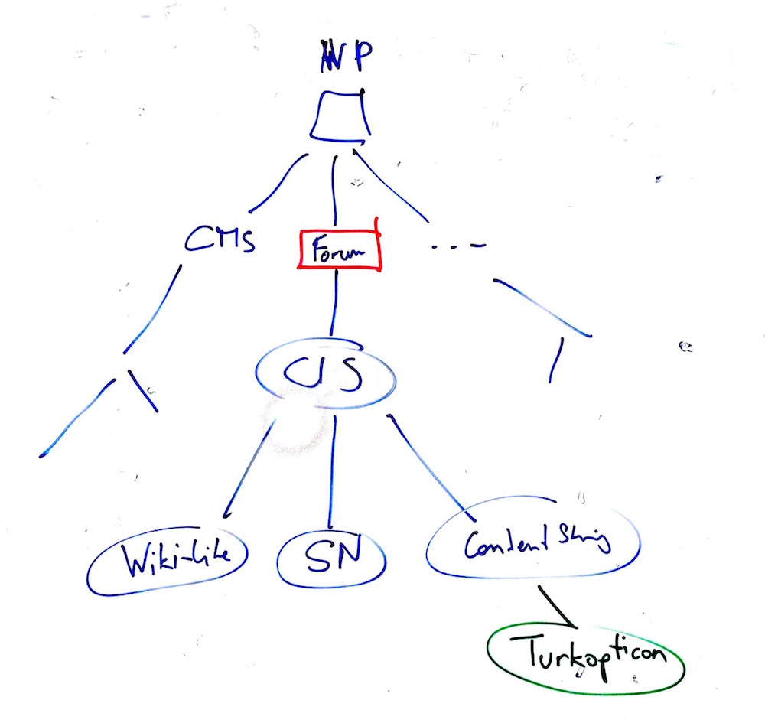

**Research Question Candidates**

Revisit with the goals and challenges in mind:

* What are the coordination and knowledge sharing needs and challenges in the crowdwork domain?
* How could software help to address these needs and limitations?
  + less an option (because would lead to SSR):
    - What is out there, so far (platforms, tools, etc?)
    - What are common limitations?

**Evaluation Concept**

* **Evaluation Goal**
  + Utility.
  + Completeness.
  + Usability and suitability with pre-existing workflows and processes.
* **Evaluation Method**
  + Case Study:
    - Elicit requirements for the new system.
    - Identify technically similar system candidates (forums, ...).
    - Prototypical Implementation of the System
      * Technology stack is based on TBA.
    - Evaluate with regarding to evaluation goals with stakeholders in form of workshop/interviews/ ...
* **Evaluation Results**
  + Identify how well the solution address needs, challenges and requirements of stakeholders (crowdworkers, Interessensvertretungen)?

**Related Work**

* Crowdwork
  + Description of the topic.
* Current State of how Crowdworkers organize.
  + see the both studies provided in Email 2017-03-16.
* Collective Intelligence Systems

Length ca. 100+ pages

**Resources**

* Latex
* ShareLatex Editor als Option

**Open Questions**

* An AK Stakeholder: Welche Daten sollen von Worker gesammelt werden?

### Next Steps

* JM: ShareLatex bei QSE Account anlegen
* JM: Send Abstract Template and 2 Example Abstracts.
* JM: Send AK Material (via Dropbox)
* JFi: Write Abstract draft.

### Next Meeting: Date: 2017-03-27, Time: 17:00, HG0111, Participants: SB, JFi, JM